Nabil Knight

2022-Feb-27

IT FDN Programming: Python

Assignment 05

Using Lists / Dictionaries, Functions and Programming Best Practices

# Introduction:

During the fifth week of the course we went over lists in more depth and began reviewing how to use dictionaries and how they are different than a list. Additionally, we covered functions a little more in preparation for next week’s material and also dove into how to use error handling. We also covered topics on how to best set yourself up for success as a programmer: formatting your .py templates, using GitHub as a repository for your code, and using separations of concerns (SoC) as a way to structure your code (even more than just using in line comments). To cap off the week we used our learnings to continue on with our CD Inventory project from last week.

# Lists Continued:

As we learned last week, lists are mutable which means they can be changed and they can hold other lists, tuples, strings, etc. within them. They even have a number of functions you can use to alter and change the list (.append, .remove, etc.). This week we learned how to unpack a list using ‘*’ when printing. The ‘*’ symbol is an overloaded operator and has multiple uses:

lstRow = []

lstRow = [1, 'Jane Doe', 'JaneD@doemail.com']

**for** item **in** lstRow:

print(*lstRow, sep = ', ')

We also covered how to read and save data to a file when using the open() function - ‘r’ and ‘w’. In many cases we use a similar for loop to cycle through the data you are writing or reading, to be able to format it in such a way that is presentable to the end user, sample code shown below:

lstRow = []

strRow = ''

strFileName = 'Example.txt'

objFile = **None**

lstRow = [1, 'Jane Doe', 'JaneD@doemail.com']

**for** item **in** lstRow:

strRow += str(item) + ', '

strRow = strRow[:-1] + '\n'

objFile = open(strFileName, 'w')

objFile.write(strRow)

objFile.close()

To open a file, you follow a similar pattern as above, you swap out the ‘w’ with an ‘r’ and you need to alter the for loop to account for the file and cleaning up the data:

objFile = open(strFileName, 'r)

for row in objFile:

lstRow = row.strip().split(',')

print(lstRow)

objFile.close()

As you can see above, you are setting a list with lstRow and looping through each row in objFile and removing the leading and trailing characters and then splitting each value on the comma. In LAB A we reused our template from the fourth weeks assignment to continue adding to the code:

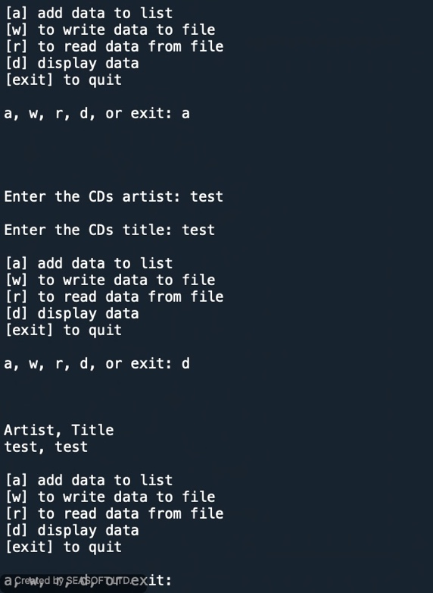

Figure - Module 5 Lab A Results

The above shows the lab working when I add a new artist and title both labeled as test and then display the results back to the user. A sample of the code is below from the read and write sections:

**elif** strChoice == 'w':

# List to File

# TODO add code here to write from in-memory list to file

cdinfo = ''

**for** row **in** lstTbl:

**for** col **in** row:

cdinfo += str(col) +','

cdinfo = cdinfo[:-1]

cdinfo += '\n'

objFile = open(strFileName, 'w')

objFile.write(cdinfo.title())

objFile.close()

**elif** strChoice == 'r':

# File to print

# TODO read the file line by line into in-memory list.

print('Artist, Title' + '\n')

lstTbl.clear()

objFile = open(strFileName, 'r')

**for** row **in** objFile:

lstRow = row.strip().split(',')

lstTbl.append(lstRow)

print(*lstRow, sep = ', ')

objFile.close()

# Dictionaries:

The next kind of sequence type we were introduced to was the dictionary; while a list, string or tuple can be accessed via an index the dictionary uses a key : value pair. The key is what stores the value, you can think of it like a name in the real world, name is the key for the value Nabil Knight. One thing to note is that a dictionary can have many different types of keys, but they cannot be changed. So, a sequence like a list will never be a key, but a string or tuple can. A dictionary is similar to a JSON object (or arrays) that is housing key: value pairs and often times nested key:value pairs. Dictionaries can be added to and there is some nuance to this in that if a key already exists the value for that key will change, while a dictionary without said key will be added to the dictionary. Dictionaries like lists and tuples have a variety of functions that you can use to alter and change the dictionary (a few below):

1. len(d): returns the number of items in the dictionary
2. clear(): removes all items from the dictionary
3. key(): returns all keys
4. values(): returns all values

Similar to a list you can have a user add data to a dictionary and also read and write data from and to a file. In our second lab – LAB B we altered the code from LAB A to use dictionaries, sample code below:

**if** strChoice == 'a': # no elif necessary, as this code is only reached if strChoice is not 'exit'

# Add data to list in memory

artist = input('Enter the CDs artist: ')

title = input('Enter the CDs title: ')

dicRow = {'Artist': artist, 'Title': title}

lstTbl.append(dicRow)

#pass

**elif** strChoice == 'w':

# List to File

cdinfo = ''

**for** row **in** lstTbl:

**for** col **in** row:

cdinfo += str(col) +','

cdinfo = cdinfo[:-1]

cdinfo += '\n'

objFile = open(strFileName, 'w')

objFile.write(cdinfo.title())

objFile.close()

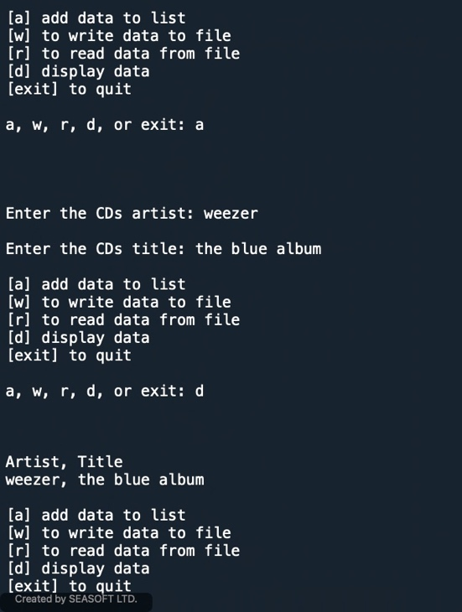

Figure - Module 5 Lab B Results

# Functions and Error Handling:

A few other topics we covered during the week were the use of error handling when user input or other circumstances may crash your programs and how to avoid them. We also reviewed how and when to use custom functions. Error handling is needed when something random such as when an invalid user input may abort your program and cause unforeseen errors like either losing data or corrupting your file. Python has a way to get around this with structure error handling, this is accomplished with the Try / Except concept. Being able to define your own custom functions not only provides a programmer with flexibility but it also provides a clean way to break up your code. Functions need to be defined before they are able to be used and a function gets loaded into memory but the code isn’t used (it only will be when it is needed later on in the program)!

# Programming Best Practices:

1. Separation of Concerns: The principle of dividing your code into separate sections, generally in ‘Data,’ ‘Processing,’ and ‘Presentation.’ As can be seen in Figure 3 below.
2. Template Formatting: This provides a clean format to begin any new project so a programmer doesn’t need to manually do this each time:

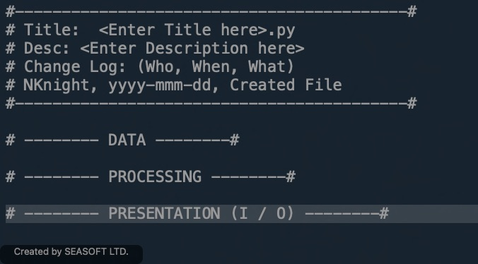

Figure - Template Formatting

1. GitHub: GitHub is a repository to be able to have version control; we created an account this week and will need to upload our assignment to be peer reviewed:

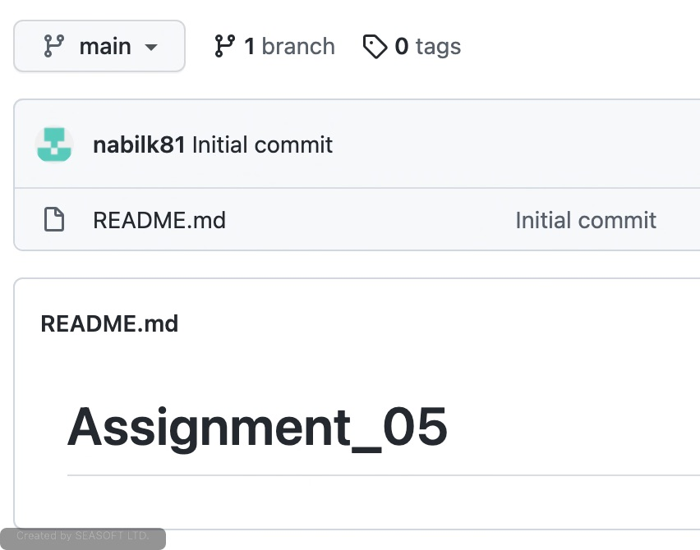

Figure - GitHub Repository

# Assignment:

To put into practice all that we learned for the week, we were tasked with using some starter code from the CD Inventory program that we used last week. Our task was to update a few of the sections to be able to load and delete data from a file while using a 2D list of dictionaries. In this week’s assignment we were not supposed to use custom functions and experience how this would affect the separation of concerns:

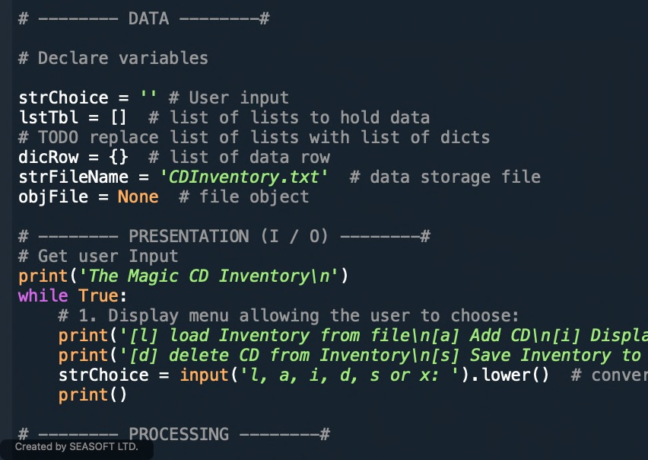

Figure – SoC

As you can see above, the SoC doesn’t follow the standard way of declaring your variables, processing your data and then presenting the data back to your user.

The flow of the program is to provide the user with a menu to load, add, display, delete, save or exit the program. In the example below, I am adding two new lines to memory and then saving them to CDInventory.txt:



Figure - Adding and Saving New Lines

In the figure below, I am loading the newly saved lines into memory (as a dictionary), adding a new line and then deleting a line:



Figure - Loading, Adding, and Deleting a line

To complete the program, I will now write the two remaining lines (ID:1 and ID:3) to file:

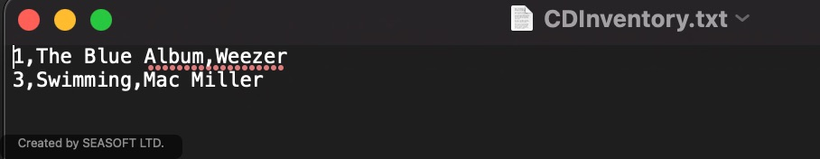

Figure - Writing to File

Please see appendix for terminal results. I was having a difficult time figuring out how to delete a line from memory. I was first trying to load data from a file and delete that line and reformat the file to only include the remaining lines. I was able to get direction from Laura and Dirk to keep each element separate and work through the problem in that manner. Code below describing my solution to delete an entry from memory:

**elif** strChoice == 'd':

entID = input('Enter the CD ID you want to delete: ')

**for** row **in** range(len(lstTbl)):

**if** lstTbl[row]['ID'] == entID:

**del** lstTbl[row]

**break**

# Conclusion:

This week we learned a lot about utilizing lists and dictionaries in partnership with each other. They are similar in that they are both mutable however, the one key difference is that a dictionary uses a key:value pair instead of an index to access it. Additionally, we began learning about ways to format our scripts better: using Separation of Concerns, using a predefined script template, using custom functions to outline and format our code in a more readable manner and using GitHub as a tool for versioning our code. To put our learnings into practice we used some starter code from last week to create a 2D list of dictionaries with our CD Inventory Menu.

# Appendix:

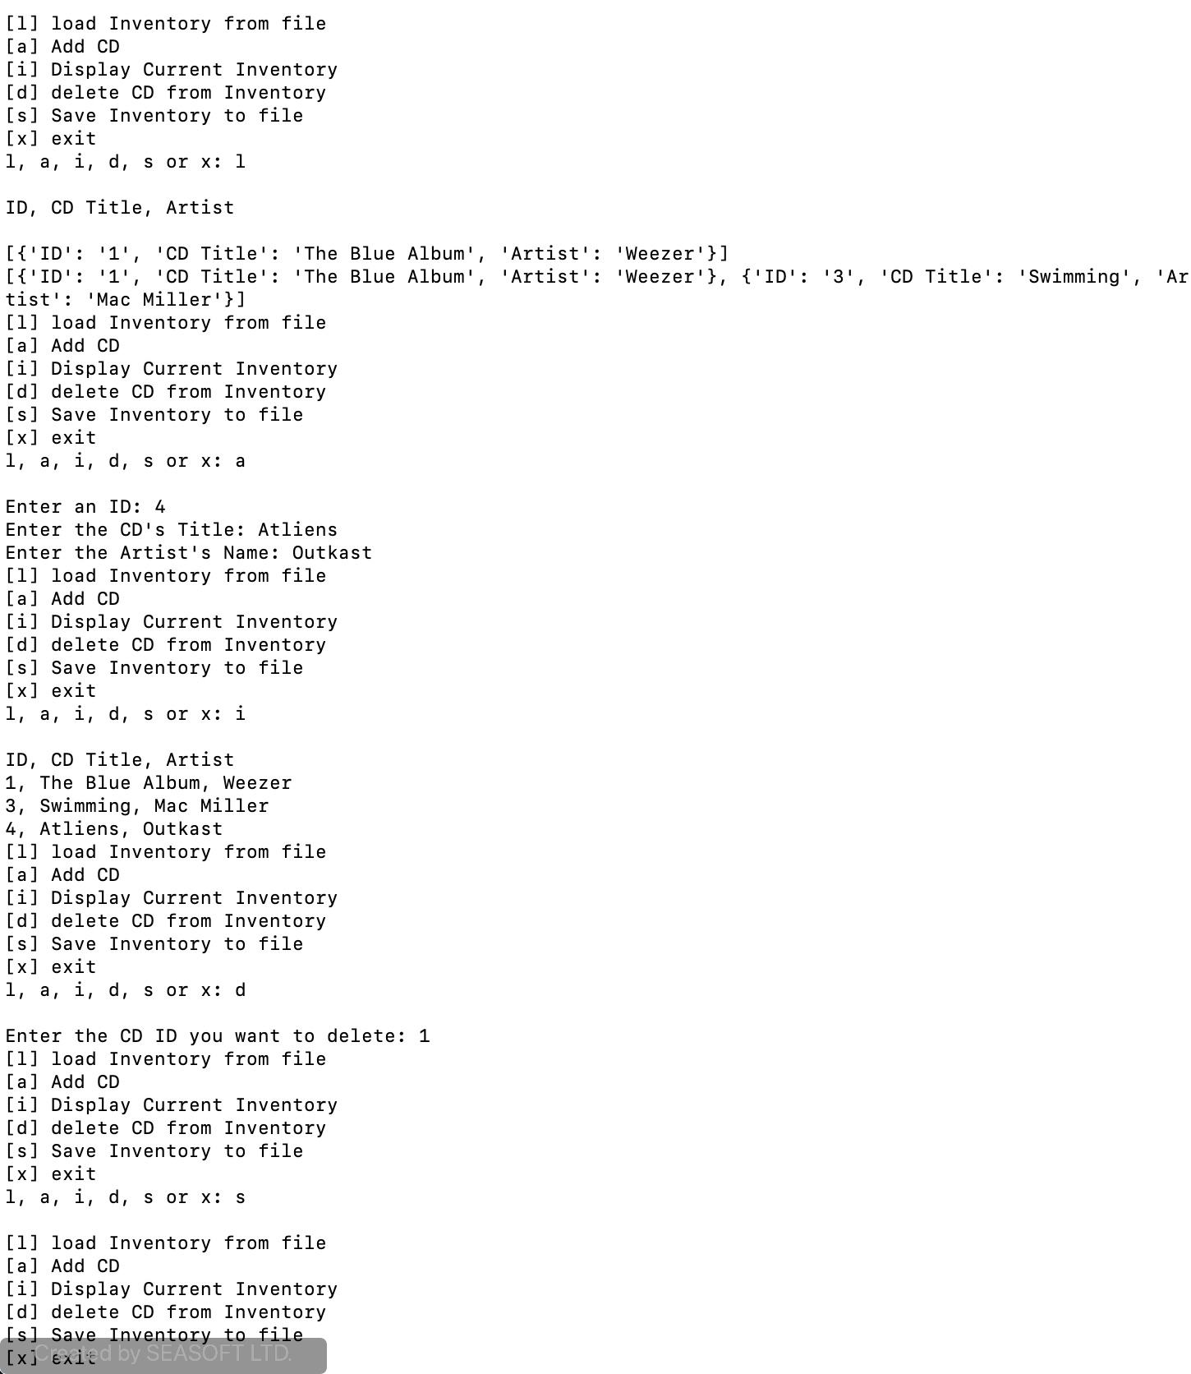

Figure 9 - Terminal Results

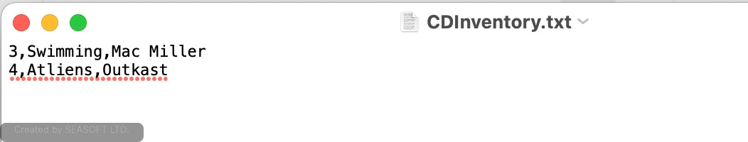

Figure 10 - Terminal .txt Results